**Gas Station**

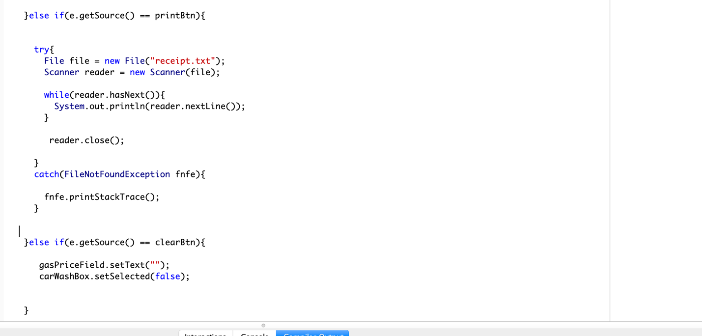

**GUI EXAMPLE:**

//Importing all our components

import javax.swing.JFrame; //our lihgtwieght main frame

import javax.swing.JLabel; // our lightweight label

import javax.swing.JPanel;

import javax.swing.JTextField;

import javax.swing.JComboBox;

import javax.swing.JCheckBox;

import javax.swing.JRadioButton;

import javax.swing.ButtonGroup; //it is not JBUttonGroup because its not a component

import javax.swing.JTextArea;

import javax.swing.JButton;

import java.awt.GridLayout;

import java.awt.BorderLayout; //its in the awt because the layout does not need to be lightweight, so we dont take it from swing

import java.awt.Color;

import javax.swing.ImageIcon;

//do not include action listener if you will not use it

import java.awt.event.ActionListener;

import java.awt.event.ActionEvent;

import javax.swing.JOptionPane;

public class GUIExample extends JFrame implements ActionListener{

//We declare our components (as variables)

private JLabel fullnameLabel,stateLabel,hobbyLabel,blankLabel, maleLabel, femaleLabel;

private ImageIcon maleIcon, femaleIcon;

private JTextField fnTextField;

private JPanel northPanel,westPanel,westPanel2,centerPanel,southPanel;

private JComboBox stateDropbox;

private JCheckBox musicBox, movieBox;

private JRadioButton maleRadioButton, femaleRadioButton;

private ButtonGroup genderGroup;

private JTextArea commentArea;

private JButton submitButton, cancelButton;

public GUIExample(){

super("My awesome GUI"); //setTitle("My java GUI")//System.out.println("hello");

//***Putting the Label component and TextField to a north Panel

northPanel = new JPanel();

//Styling

northPanel.setBackground(Color.BLUE);

//Label component

fullnameLabel = new JLabel("Enter Full Name:");

fullnameLabel.setForeground(Color.WHITE);

add(fullnameLabel,BorderLayout.NORTH);

//TextFieldComponent

fnTextField = new JTextField(5);

northPanel.add(fullnameLabel);

northPanel.add(fnTextField);

westPanel = new JPanel();

westPanel.setLayout(new GridLayout(3,2));

//StateLabel

stateLabel = new JLabel("State");

//Dropbox

String states [] = {"","DC","MD","VA"};

stateDropbox = new JComboBox(states);

//HobbyLabel

hobbyLabel = new JLabel("Hobbies:");

hobbyLabel.setToolTipText("Tips here!");

//Checkboxes

blankLabel = new JLabel("");

musicBox = new JCheckBox("Music");

movieBox = new JCheckBox("Movies");

westPanel.add(stateLabel);

westPanel.add(stateDropbox);

westPanel.add(hobbyLabel);

westPanel.add(blankLabel);

westPanel.add(musicBox);

westPanel.add(movieBox);

westPanel2 = new JPanel();

westPanel2.add(westPanel);

//Center

//RadioButtons

maleRadioButton = new JRadioButton("");

femaleRadioButton = new JRadioButton("");

genderGroup = new ButtonGroup();

genderGroup.add(maleRadioButton);

genderGroup.add(femaleRadioButton);

maleIcon = new ImageIcon("male.gif");

femaleIcon = new ImageIcon("female.gif");

maleLabel = new JLabel(maleIcon);

femaleLabel = new JLabel(femaleIcon);

centerPanel = new JPanel();

centerPanel.add(maleLabel);

centerPanel.add(maleRadioButton);

centerPanel.add(femaleLabel);

centerPanel.add(femaleRadioButton);

//CommentArea

commentArea = new JTextArea(5,10);

//South

southPanel = new JPanel();

submitButton = new JButton("Submit");

submitButton.addActionListener(this);

cancelButton = new JButton("Cancel");

cancelButton.setBackground(Color.RED);

cancelButton.addActionListener(this);

southPanel.add(submitButton);

southPanel.add(cancelButton);

//***Adding our panels to our JFrame

add(northPanel,BorderLayout.NORTH);

add(commentArea,BorderLayout.EAST);

add(centerPanel,BorderLayout.CENTER);

add(southPanel,BorderLayout.SOUTH);

add(westPanel2,BorderLayout.WEST);

//Our mainframe settings

setSize(600,500);

setVisible(true);

setDefaultCloseOperation(JFrame.EXIT_ON_CLOSE);

}

public void actionPerformed(ActionEvent event){

if(event.getSource() == submitButton){

String fullname = fnTextField.getText();

String comment = commentArea.getText();

String state = stateDropbox.getSelectedItem().toString();

String movie = "No";

String music = "No";

if(movieBox.isSelected()){

movie = "Yes";

}else{

movie = "No";

}

if(musicBox.isSelected()){

music = "Yes";

}else{

music = "No";

}

String gender = "";

if(maleRadioButton.isSelected()){

gender = "male";

}

if(femaleRadioButton.isSelected()){

gender = "female";

}

String output = "Full name: "+ fullname +

"\nComment: " + comment +

"\n State: " + state +

"\n Movie? " + movie +

"\n Music? " + music +

"\n Gender: " + gender;

JOptionPane.showMessageDialog(null,output);

}else if(event.getSource() == cancelButton){

fnTextField.setText("");

commentArea.setText("");

stateDropbox.setSelectedIndex(0);

musicBox.setSelected(false);

movieBox.setSelected(false);

genderGroup.clearSelection();

}

}

public static void main(String [] args) {

GUIExample app = new GUIExample();

}

}

**Actions and Events**

About:

-You add an actionListener to a component

-Then you define the event handler using ActionEvent

How:

**Import java.awt.event.ActionListener;**

**Import java.awt.event.ActionEvent;**

Public class MyClass extends Jframe **implements ActionListener**{

//Inside our constructor

Public MyClass(){

//Adding an event will look like this

submitButton = new Jbutton("Submit");

**submitButton.addActionListener(this);**

--> so the handler is tied to the handler defined in this class

}

//This is our eventHandler :)

**public void actionPerformed(ActionEvent event ){**

**if(event.getSource() == submitButton){**

//handling stuff to do

}

else if(event.getSource() == clearButton){

//handling stuff to do

}

}

}

Stuff that goes inside the actionPerfomed event handler:

String fullname = fnTextField.getText();

String comment = commentArea.getText();

String state = stateDropbox.getSelectedItem().toString();

String movie = "No";

String music = "No";

if(movieBox.isSelected()){

movie = "Yes";

}else{

movie = "No";

}

if(musicBox.isSelected()){

music = "Yes";

}else{

music = "No";

}

String gender = "";

if(maleRadioButton.isSelected()){

gender = "male";

}

if(femaleRadioButton.isSelected()){

gender = "female";

}

String output = "Full name: "+ fullname +

"\nComment: " + comment +

"\n State: " + state +

"\n Movie? " + movie +

"\n Music? " + music +

"\n Gender: " + gender;

JOptionPane.showMessageDialog(null,output);

To clear form values:

fnTextField.setText("");

commentArea.setText("");

stateDropbox.setSelectedIndex(0);

musicBox.setSelected(false);

movieBox.setSelected(false);

genderGroup.clearSelection();

* 1 
  2 
  3 
  4 
  5 
  6 
  7 
  8 
  9 
  10 
  11 
  12 
  13 
  14 
  15 
  16 
  17 
  18 
  19 
  20 
  21 
  22 
  23 
  24 
  public class DivideAndException 
  public static void main(String C] args){ 
  int numerator = 
  10 • 
  int denominator = 
  o; 
  try{ 
  int result 
  = numerator / denominator; 
  System. out. println("Result: "+ result); // everything inside try block 
  // We use this way to catch any exception 
  catch(Exception e) { 
  System. out . println(e . toString()) ; 
  System. out . println(e . getMessage()) ; 
  e . printStackTrace() ; 
  System. out. print("End successfully"); 
  --> if everything is valid this 

* 1 
  2 
  3 
  4 
  5 
  6 
  7 
  8 
  9 
  10 
  11 
  12 
  13 
  14 
  15 
  16 
  public class DivideByZeroException extends Exception { 
  public DivideByZeroException(){ // This is our constructor 
  super("Error: Can't divide by Zero! ! 
  public DivideByZeroException(String message){ 
  //Creating a second constructor, 
  super(message); 
  to allow the 
  'user' 
  program to pass any message... they want 

* public class DivideAndException2 
  public static void main(String C] args){ 
  int numerator = 
  10 • 
  int denominator = 
  try{ 
  // you have to specify what you try to catch, when you create your own exception 
  if(denominator 
  // detecting the error 
  // if this error happens, we pass the control to the catch block 
  throw new DivideByZeroException("You cant divide by zeroooo"); 
  int result 
  = numerator / denominator; 
  System. out. "+ result); 
  catch(DivideByZeroException e) { 
  System. out . println(e . toString()) ; 
  // System. out . println(e . getMessage()); 
  // e.printStackTrace(); 
  System. out. print("End successfully"); 
  // everything inside try block 
  --> if everything is valid this happens 

**Input/Output**

-How to read from files

-How to write to files

Reading from:

import 
import 
import 
public 
java. io. File; 
java. io. Fi leNotFoundException ; 
java. util . Scanner; 
class ReadFromFile{ 
public static void main(String C] args){ 
File file 
= new txt"); 
try { 
= new Scanner(file); 
Scanner reader 
// System. out. println(reader. nextLine()); can crash easily 
while(reader . 
System. out . println(reader . nextLine()) ; 
can also do: 
String line 
= reader. nextLine(); 
System. out . println(line); 
reader . close(); 
catch(FileNotFoundException fnfe){ 
fnfe . printStackTrace() ; 

Writing to:

1 
2 
3 
4 
5 
6 
7 
8 
9 
10 
11 
12 
13 
14 
15 
16 
17 
18 
19 
20 
21 
22 
23 
24 
25 
26 
28 
29 
30 
31 
mport 
import 
import 
public 
java. io. File; 
java. io. FileWriter; 
java. io. IOException ; 
class WriteToFile { 
public static void main(String C] args){ 
File file 
= new txt"); 
String sample Txt = 
"Marymount University" ; 
try{ 
FileWriter writer 
= new FileWriter(file); 
// FileWriter writer 
= new FileWriter(file,true); 
writer . hiimaaaaa"); 
writer . write(sampleTxt) ; 
writer. write("\nHappy Galentines dayy"); 
writer . close(); 
catch(IOException ioe){ 
System. out . println(ioe . toString()) ; 
// to keep the old content/ to append text 